**DIGI HEALTH**

**By**

**Sharjeel Ahmed (K20-0288)**

**Syed Ahzam Imam (K20-1612)**

**Introduction**

This application solves the real-life problem of the health sector the main features include  
detection of disease using AI (machine learning)

The user has to enter the symptoms and the Application comes up with the prediction more over you have direct access to a doctor you can call/email whatever you like.

The patient history is also maintained

Several AI tests can predict your disease one of them is brain tumor detection using an MRI scan

This project is inspired by the UK digit AI health system although it has extra features like AI disease prediction. The main aim of this application is to ease the process for patients   
we are likely to include many other features like virtual consultation. E-Pharmacy and availability of wards vent etc.

Here are the snips of the application

* **OnBoarding screen**

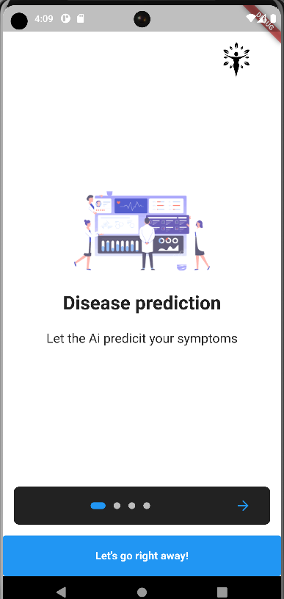

* **Login screen**

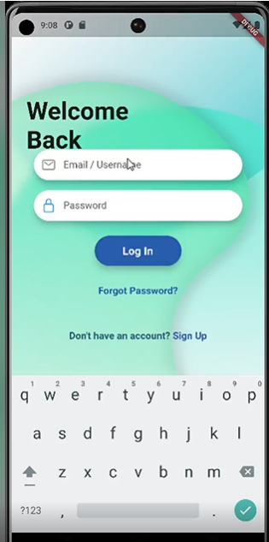

* **Signup screen**

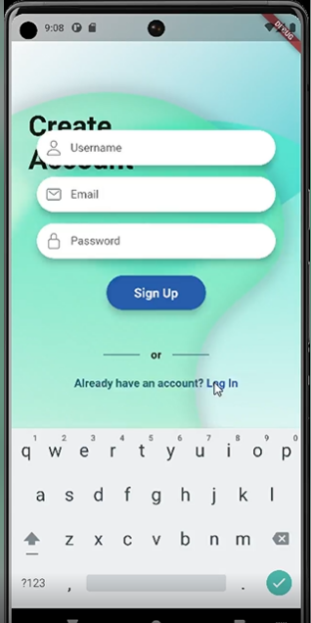

* **User settings**

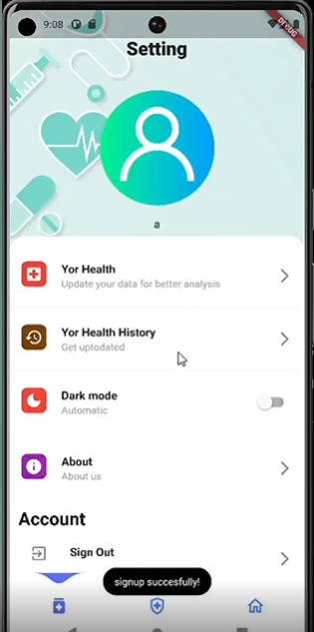

* **User basic biometrics**

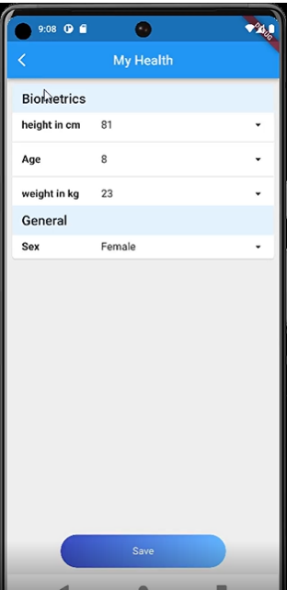

* **Feature screen where user can see his steps, BMI, and heart rate and analyze his/her symptoms**

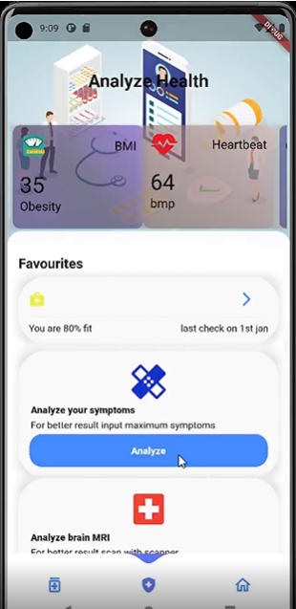

* **Disease prediction/analyze**

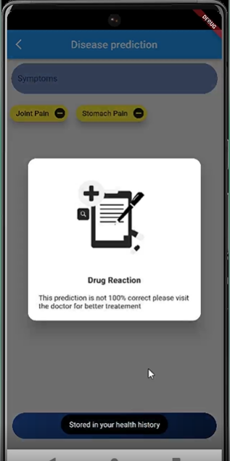

* **User history**

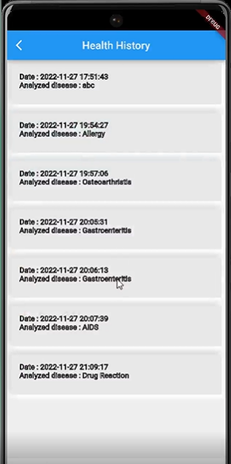

* **Doctors Screen**

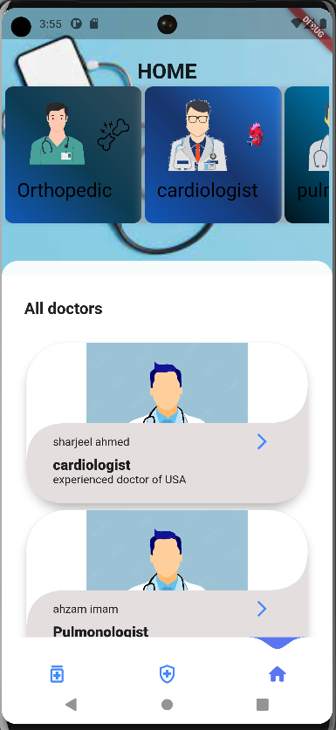

* **Doctors information Screen**

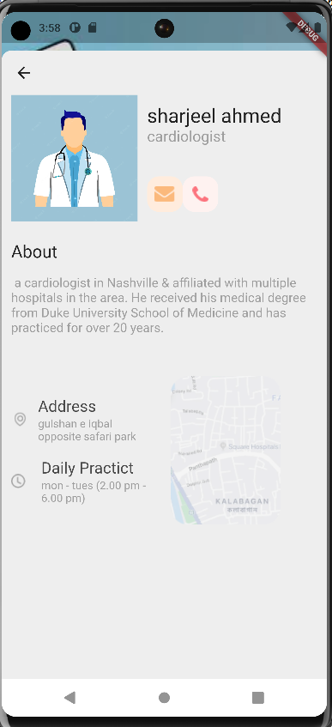

**Normalization**

|  |  |  |  |  |  |  |  |
| --- | --- | --- | --- | --- | --- | --- | --- |
| User_ID | Prediction | Date | Doctor_ID | Doctor_name | Doctor_designation | Doctor_description | Doctor_about |
| Doctor_days | Doctor_hours | Doctor_contact | Doctor_email | Doctor_category | Height | Weight | Age |
| Sex | Time | User_name | User_email | User_password |  |  |  |

**1st NF**

|  |  |  |
| --- | --- | --- |
| User_id | Prediction | date |

|  |  |  |  |  |  |  |
| --- | --- | --- | --- | --- | --- | --- |
| Doctor_id | Doctor_name | Doctor_designation | Doctor_Description | Doctor_about | Doctor_days | Doctor_address |
| Doctor_contact | Doctor_email | Doctor_category |  |  |  |  |

|  |  |  |  |  |  |  |  |
| --- | --- | --- | --- | --- | --- | --- | --- |
| User_id | Height | Weight | Sex | Age | Username | User_password | User_email |

**2nd NF**

|  |  |  |  |  |  |  |  |
| --- | --- | --- | --- | --- | --- | --- | --- |
| Doctor_id | Doctor_hours | Doctor_about | Doctor_days | Doctor_address | Doctor_contact | Doctor_email | Doctor_category |

|  |  |  |
| --- | --- | --- |
| User_id | Prediction | date |

|  |  |  |  |
| --- | --- | --- | --- |
| Doctor_id | Doctor_designation | Doctor_Description | Doctor_name |

|  |  |  |  |  |  |
| --- | --- | --- | --- | --- | --- |
| User_id | Height | Weight | Sex | Age | time |

**3rd NF**

Already in 3rd NF and BCNF

Two more tables used for triggers were already normalized

Min-max Diagram

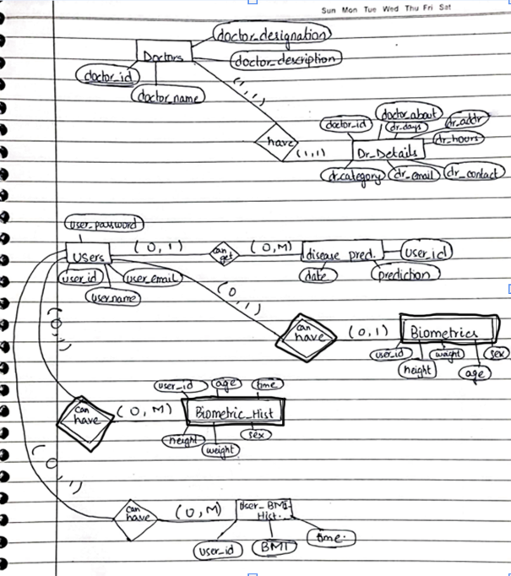

**Logical Model**

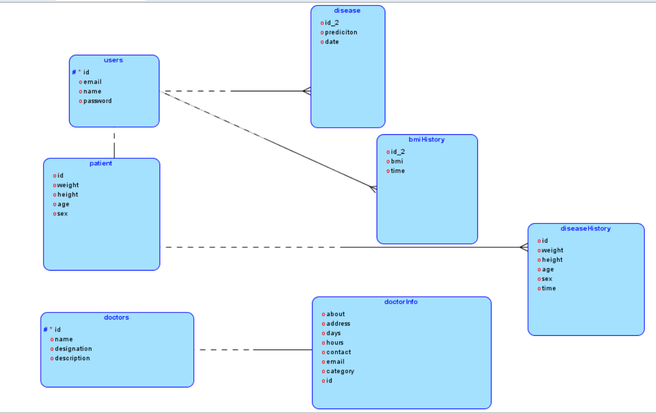

**Relational model**

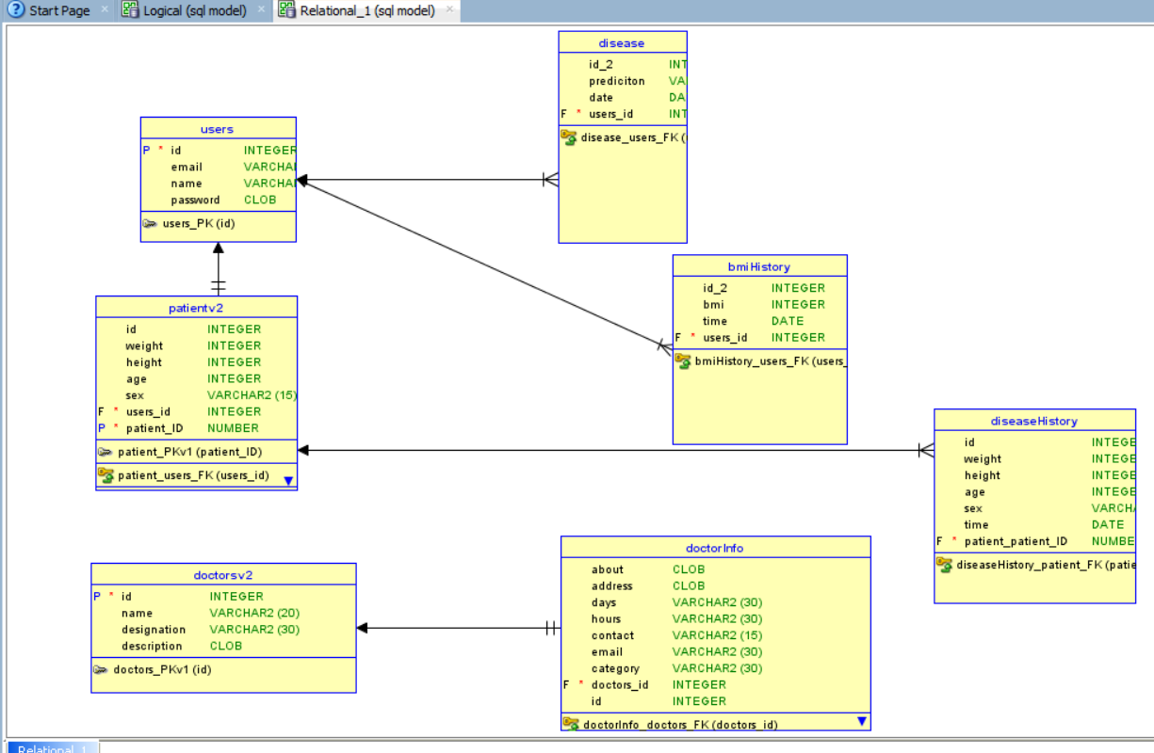

**Technologies**

We use flutter for our front end because of its cross-platform advantage.

Python to train our models which include NumPy, pandas, SciPy, matplotlib, seaborn, sklearn, joblib

To integrate this model with our flutter application we use flask

PHP is used to integrate our database into the flutter application and MySQL is used as our database

The app can run on both android and iOS.

**Conclusion**

This application is a vast project as it needs many features and views for different professionals e.g., doctors, hospitals, etc.

We are likely to gather more data for better model predictions

And integrate it with a website so all the hospitals can directly be involved in the system’s betterment.